Student 'Quick' Impact Session
Interviews with Students from Hamble Community Sports College

Selected interviewers are students who represent the college from a wide range variety of leadership areas including from Sport, Technology, Digital and the Creative Arts. Interviews will be timed. Each interview is scheduled for two minutes, with a brief period for formal introductions and movement between interviews. A timer will be displayed. To facilitate this process you have been provided with the student’s names and a plan of the room. If there is a third student at your interview, it is where our reserve students have been included or students are moderating the process. If there has been a change to your interviewer, the students have been asked to introduce themselves. Please feel free to leave your personal effects in the conference room as you will be accompanied back here in order to prepare for your second activity. I look forward to welcoming to the college, and I know that our students are very keen to hear your views and opinions too.
Pairing | Interviewer 1 | Interviewer 2 |  | Time |  | Your Next Activity
1 |  |  |  | 08:36 |  | Teach
2 |  |  |  | 08:40 |  | Teach
3 |  |  |  | 08:44 |  | Teach
4 |  |  |  | 08:48 |  | Teach
5 |  |  |  | 08:52 |  | Tour
6 |  |  |  | 08:56 |  | Tour
7 |  |  |  | 09:00 |  | Tour
8 |  |  |  | 09:04 |  | Tour
R

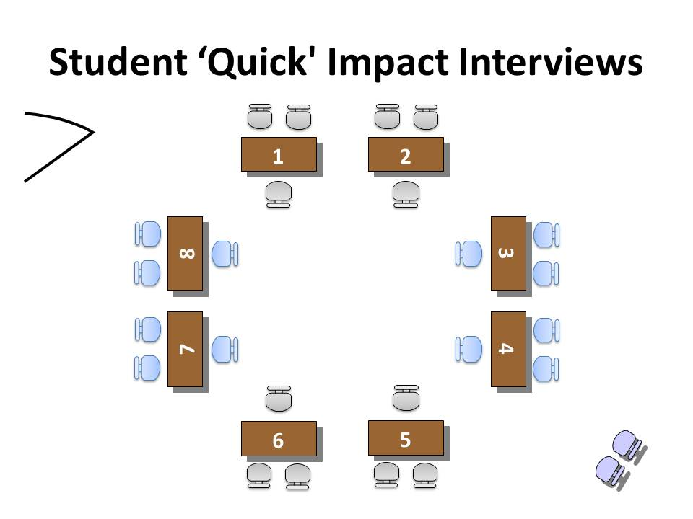
Questions

Interviewer 1 | Interviewer 2 | Question 1 | Question 2 | Back Up Question
 |  | What are your thoughts on our partnership with Ferndale School in South Africa? | How would you describe yourself when you were a student at school? | How important is our schools sport specialism?
 |  | Briefly, can you name the most important qualities that in your opinion, makes a great teacher? | What skills can you bring from previous teaching positions and that would benefit our college? | How important is student leadership in a school?
 |  | Can you describe the future that you see for the college, for the teachers and for the students? | How would you celebrate when a student or teacher has done well? | How important are school trips?
 |  | What subject do you specialise in? How does it reflect your personality? | How would you deal with inappropriate student behaviour outside the classroom? | How important are mentor sessions?
 |  | How would you help a student who was behind or struggling with their work? | What drives your determination to succeed, not only for yourself but for the students and staff at Hamble College? | How important are parent and carer meetings, or parent or carer evenings.
 |  | Instead of telling a student what they did wrong, how would you tell them to do it right next time? | How would you praise a student who did an exceptional piece of work? | How important are school performances?
 |  | How would you deal with disruptive, but able student, in top sets? | How and where would you make a difference to our college? | How important are assemblies?
 |  | How would you help our teachers do a good, and better, job? | What are two the main reasons you want to be our Vice Principal? Just two please. | How important is school uniform?

Feedback 1

Interviewers

 | Question 1 | Question 2 | Back Up Question
 | What are your thoughts on our partnership with Ferndale School in South Africa? | How would you describe yourself when you were a student at school? | How important is our schools sport specialism?
1
2
3
4
5
6
7
8

Summary

The candidate that answered your questions the best | 1 | 2 | 3 | 4 | 5 | 6 | 7 | 8
The candidate that left a lasting impression | 1 | 2 | 3 | 4 | 5 | 6 | 7 | 8

Feedback 2

Interviewers

 | Question 1 | Question 2 | Back Up Question
 | Briefly, can you name the most important qualities that in your opinion, makes a great teacher? | What skills can you bring from previous teaching positions and that would benefit our college? | How important is student leadership in a school?
1
2
3
4
5
6
7
8

Summary

The candidate that answered your questions the best | 1 | 2 | 3 | 4 | 5 | 6 | 7 | 8
The candidate that left a lasting impression | 1 | 2 | 3 | 4 | 5 | 6 | 7 | 8

Feedback 3

Interviewers

 | Question 1 | Question 2 | Back Up Question
 | Can you describe the future that you see for the college, for the teachers and for the students? | How would you celebrate when a student or teacher has done well? | How important are school trips?
1
2
3
4
5
6
7
8

Summary

The candidate that answered your questions the best | 1 | 2 | 3 | 4 | 5 | 6 | 7 | 8
The candidate that left a lasting impression | 1 | 2 | 3 | 4 | 5 | 6 | 7 | 8

Feedback 4

Interviewers

 | Question 1 | Question 2 | Back Up Question
 | What subject do you specialise in? How does it reflect your personality? | How would you deal with inappropriate student behaviour outside the classroom? | How important are mentor sessions?
1
2
3
4
5
6
7
8

Summary

The candidate that answered your questions the best | 1 | 2 | 3 | 4 | 5 | 6 | 7 | 8
The candidate that left a lasting impression | 1 | 2 | 3 | 4 | 5 | 6 | 7 | 8

Feedback 5

Interviewers

 | Question 1 | Question 2 | Back Up Question
 | How would you help a student who was behind or struggling with their work? | What drives your determination to succeed, not only for yourself but for the students and staff at Hamble College? | How important are parent and carer meetings, or parent or carer evenings.
1
2
3
4
5
6
7
8

Summary

The candidate that answered your questions the best | 1 | 2 | 3 | 4 | 5 | 6 | 7 | 8
The candidate that left a lasting impression | 1 | 2 | 3 | 4 | 5 | 6 | 7 | 8

Feedback 6

Interviewers

 | Question 1 | Question 2 | Back Up Question
 | Instead of telling a student what they did wrong, how would you tell them to do it right next time? | How would you praise a student who did an exceptional piece of work? | How important are school performances?
1
2
3
4
5
6
7
8

Summary

The candidate that answered your questions the best | 1 | 2 | 3 | 4 | 5 | 6 | 7 | 8
The candidate that left a lasting impression | 1 | 2 | 3 | 4 | 5 | 6 | 7 | 8

Feedback 7

Interviewers

 | Question 1 | Question 2 | Back Up Question
 | How would you deal with disruptive, but able student, in top sets? | How and where would you make a difference to our college? | How important are assemblies?
1
2
3
4
5
6
7
8

Summary

The candidate that answered your questions the best | 1 | 2 | 3 | 4 | 5 | 6 | 7 | 8
The candidate that left a lasting impression | 1 | 2 | 3 | 4 | 5 | 6 | 7 | 8

Feedback 8

Interviewers

 | Question 1 | Question 2 | Back Up Question
 | How would you help our teachers do a good, and better, job? | What are two the main reasons you want to be our Vice Principal? Just two please. | How important is school uniform?
1
2
3
4
5
6
7
8

Summary

The candidate that answered your questions the best | 1 | 2 | 3 | 4 | 5 | 6 | 7 | 8
The candidate that left a lasting impression | 1 | 2 | 3 | 4 | 5 | 6 | 7 | 8

Tally

 | Best Answers  Votes | Lasting impression  Votes | Rank | Comments
1
2
3
4
5
6
7
8

